

What do you do if you are not happy with something in school?

That’s not fair

I wish that could be different…

I think it shouldn’t be like that

Complaints Procedure for Children
at
Ironville and Codnor Park Primary School



Who is the best person to ask/tell?
Hayley Thomas
Questions or queries about food and the school meals.
Mrs Smedley
Questions or queries about PSHEE lessons, first aid lessons or sex and relationship lessons or swimming.
Mrs Moore
Questions or queries about clubs or school visits.
Mrs Fantom
Questions or queries about clearning or lunchtimes..
Mrs Booth
Questions or queries about History or Geography or anything about Eagles.
Mr Judge
Questions or queries about Computing or PE lessons or competitions or anything about Wrens.
Mr Garrard
Questions or queries about Maths or Science or anything about Kingfishers.
Mrs Bowler
Questions or queries about English: Reading, Writing, Phonics; school visits or Assessments or anything about Kestrels.




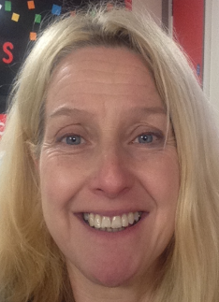

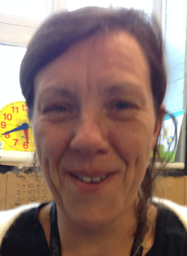



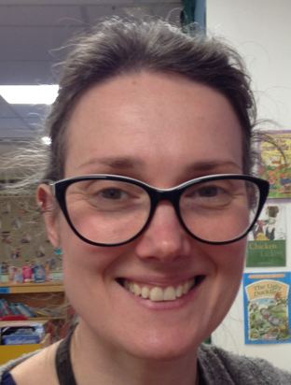


School Council
Your Class Councillors



School Council Meetings take place usually each month – tell your class councillors if you’d like something to change.

What shall I do?....
Decision will be taken back to either the individual or class who may decide to talk to the Headteacher about their idea/complaint.
Decision or solution based on
- Money
- Resources (staff, time)
Complaint or concern gets taken to the school council which may be taken to the Senior Leadership Team in school.
Write the concern or complaint into the ‘Chameleon Complaint Box’.
Tell any member of the school council.
Tell the adult who is in charge of the subject.

