Summer 2026
Kingfishers Class
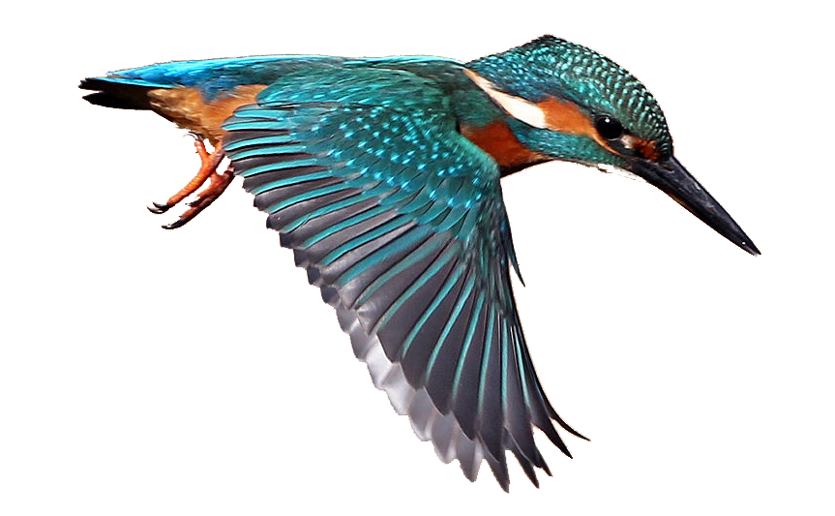
DT
We will be:
- Construction – making castles

Art
- Printing

Geography:
We are going to be learning about:
Volcanoes.
This will include looking at where volcanoes are across the world. We will research facts about volcanoes including how they are formed and why do they erupt. We will also look at the impact they have on those who live near them.
History:
During our History work we will at the purpose of a castle. What era castles built and why they built them. We will also look at who lived in castles and what was their purpose.

English:
We will be using Jane Considine scheme of work and looking at the following units:
- Entertain: Year 2 – Narrative - George and the Dragon by Christopher Wormell – (4 weeks) Wrens
- Inform: Year 2 - Neil Armstrong by Brad Meltzer Non-fiction- Recount- (4 weeks) Eagles
- Inform: Year 2 -Grace Darling by The BBC Non-fiction –Biography- (3 weeks) New teacher
- Debate – based on the Wonderful World country
RE:
- What does it mean to be a Christian?
PSHEE:
- Money Matters
- Managing loss and changes.
Music:
- Changes in Pitch, Tempo and Dynamics
- Samba and carnival sounds
Computing
Using the purple mash units:
- Presenting ideas.
- Simulations
In online safety:
- Privacy
- Copyrights
Science:
In science we are learning about:
- Plants
- Different scientific enquiries
- Planning and carrying out experiments.

PE:
- PE coach:
- Striking/fielding
- Net games
- Swimming (Year 3s)
Maths:
- Money
- Mass and Capacity
- Time
- Position and Direction

